**Exercise 3: Stored Procedures**

Scenario 1: The bank needs to process monthly interest for all savings accounts.

**PL/SQL Code:**

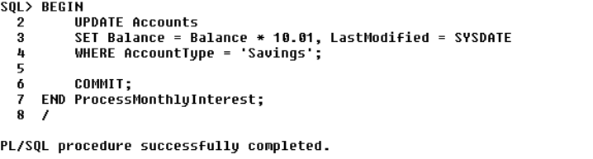

**Output:**

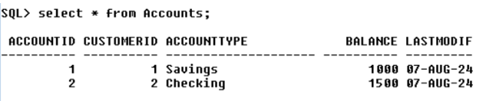

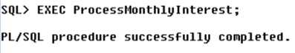

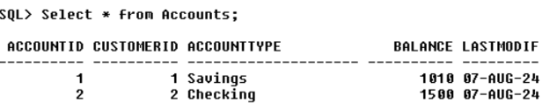

Scenario 2: The bank wants to implement a bonus scheme for employees based on their performance.

**PL/SQL Code:**

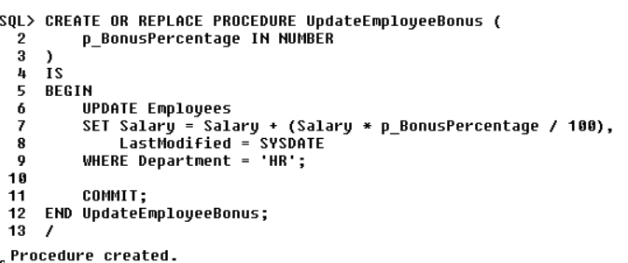

**Output:**

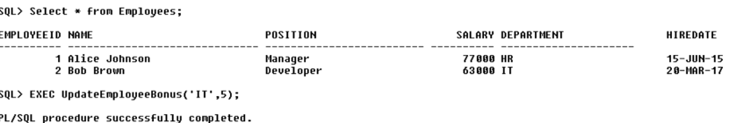

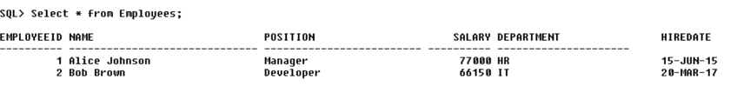

Scenario 3: Customers should be able to transfer funds between their accounts.

**PL/SQL Code:**

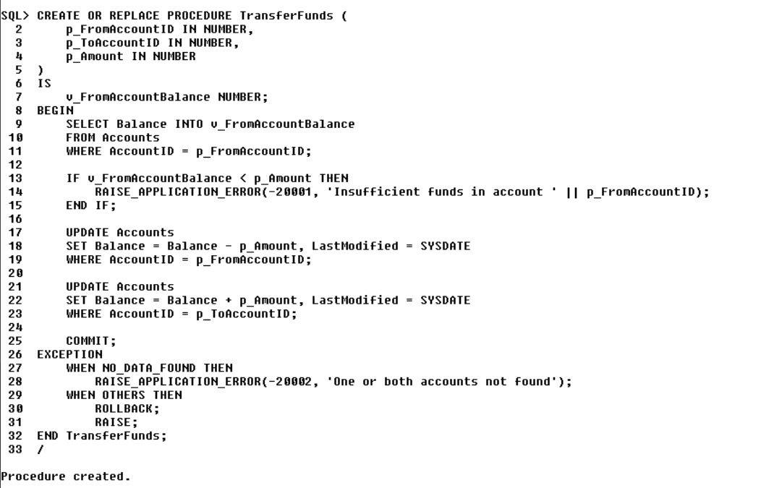

**Output:**

